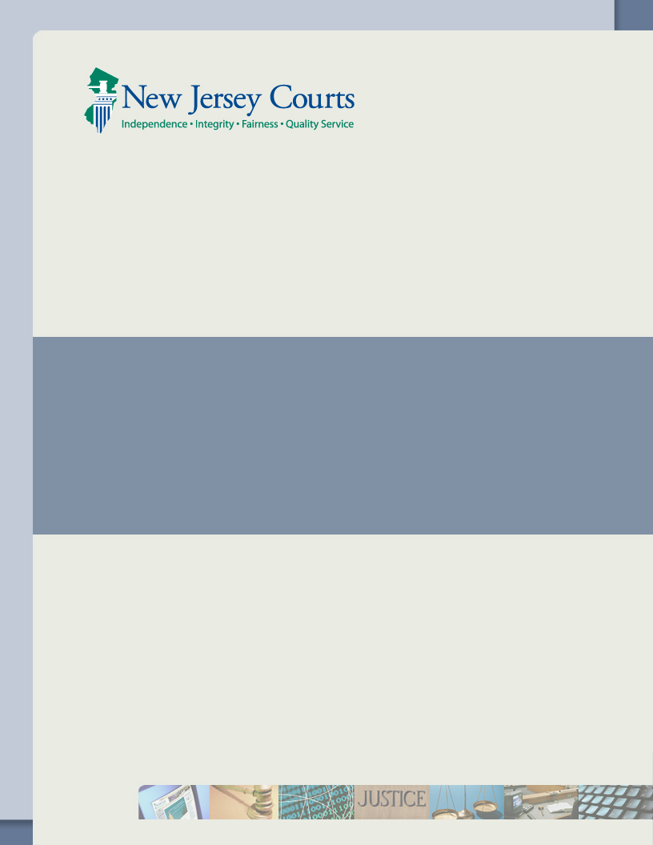

Bulk Filing

September 22, 2016

**Table of Contents**

Introduction 2

Scope 2

Purpose 2

Intended Audience 2

Validation Rules 2

Error Codes 6

Environments & End Points 6

Security and Authentication 7

Law Firm testing Environment 7

Production Environment 7

Webservice Security 7

Service Availability 8

Registering for ECourts 8

Appendix 10

WSDL and Schema 10

Accepted Values 10

Text 10

File Name character list 10

Code Tables 10

Sample SOAP Messages 11

Message1 11

Message2 11

Sample responses 13

Success Response 13

Failure Response 14

Class Diagrams 15

CivilFilingRequest 15

BulkFilingPacket 16

CivilFilingResponse 17

Frequently Asked Questions 18

## Introduction

### Scope

CivilFilingWS enables the users to file Special Civil District Court complaints.

### Purpose

The purpose of this document is to provide guidelines to integrate Civil Filing to ECourts civil filing application utilizing Web Services

### Intended Audience

Attorney firms that signed up for bulk filing

Operations  
The webservice has two operations

* submitCivilFiling
* getCivilFilingStatus

**submitCivilFiling:** Enables the user to file a new civil case. It accepts CivilFilingRequest as the input and CivilFilingResponse will be the output. On successful filing submission, the web service will return docket number and efiling sequence number.

Any application errors or validation failures will be captured in the Response objects Message List. Refer to Response Object class diagram

**getCivilFilingStatus:** If the filing is submitted when application is unavailable or during downtime, such filings will be sent to queue and processed as part of the daily batch. getCivilFilingStatus operation accepts efiling sequence number as the input and returns true if the queued filing is processed, false otherwise.

## Validation Rules

The following table has the validation rules and acceptable values for the request object

| **Field on UI** | **Java Object** | **Required** | **Accepted values** | **Comments** | |
| --- | --- | --- | --- | --- | --- |
| **Case Data – BulkFilingPacket (Refer to the** **class diagram** **for object structure)** | | | | | |
| Attorney Id | attorneyId | Yes | Nine digit numeric value |  | |
| Attorney Firm Id | attorneyFirmId | Yes | Nine digit alphanumeric value |  | |
| Branch Id | BulkFilingPacket🡪attributes | Yes | Pass the branch id of the firm the case is filed from. In the attribute, Name should be “**branchId**” and value should be the branch number |  | |
| **Case Data – BulkFilingPacket 🡪 Case (Refer to the** **class diagram** **for object structure)** | | | | | |
|  |  |  |  |  | |
| Court Section | courtSectionCode | Yes | SCP |  | |
| Venue | venueCode | Yes | Three letter venue code. Refer to County tab in the Code Table spreadsheet |  | |
| Certification text | otherCourtAction | Yes | Y |  | |
| Action | caseActionCode | Yes | Three digit numeric code. Refer to Case Action tab in the Code Table spreadsheet |  | |
| Demand Amount | demandAmountCode | Yes | A numeric field, with an exception of “.” Must be less than 15000 and accepts up to two decimals.  Ex. 10000.00 |  | |
| Jury Demand | juryDemand | Yes | N – None  S – 6 Jurors |  | |
| Service Method | serviceMethodCode | Yes | 03 |  | |
| Law Firm Case ID | lawFirmCaseId | No | Should be alpha numeric and can accept up to 20 characters |  | |
| County Of Incident | venueOfIncidentCode | Yes | Three letter venue code. Refer to County tab in the Code Table spreadsheet |  | |
| Plaintiff Caption | BulkFilingPacket 🡪 plaintiffCaption | No | Max length 123 characters and accepts only text |  | |
| Defendant Caption | BulkFilingPacket🡪 defendantCaption | No | Max 123 characters and accepts only text |  | |
|  | BulkFilingPacket🡪attributes | No | Array of attributes for any additional data |  | |
| **Party – Plaintiff : BulkFilingPacket 🡪 plaintiffList** | | | | | |
| Party Description | partyDescription | Yes | BUS – Business  IND – Individual |  | |
| Party Affiliation | partyAffiliation | No | Refer to Party Affiliation tab in the Code Table spreadsheet |  | |
| Corporation Type | corporationType | Yes, for business | Refer to Corporation type tab in the Code Table spreadsheet |  | |
| Name | corporationName | Yes, for business | Max 30 characters and accepts only text |  | |
| Phone | phoneNumber | No | Max 10 digits |  | |
| Interpreter Needed | interpreter | Yes | Y/N |  | |
| Language | language | Yes if interpreter is Y | Refer to Language tab in the Code Table spreadsheet |  | |
| Accommodation needed | adaAccommodation | Yes | Y/N |  | |
| Accommodation requirement | accommodationType | Yes if accommodation needed is Y | Refer to Accommodation Details tab in the Code Table spreadsheet |  | |
| Additional accommodation details | accommodationAdditionalDetails | No | Max length 50 and can accept only text |  | |
|  | BulkFilingPacket🡪attributes | No | Array of attributes for any additional data |  | |
| **Name** - **BulkFilingPacket 🡪 plaintiffList 🡪 Name** | | | | | |
| FirstName | Name.firstName | Yes, for Individuals | Max 9 characters and accepts only text |  | |
| Middle Initial | Name.middleName | Yes, for Individuals | A single character middle name accepts only text |  | |
| Last Name | Name.lastName | Yes, for Individuals | Max 20 characters and accepts only text |  | |
| **Address** - **BulkFilingPacket 🡪 plaintiffList 🡪 Address** | | | | | |
| Address Line 1 | address.addressLine1 | Yes | Max length 36 and accepts only text |  | |
| Address Line 2 | address.addressLine2 | No | Max 36 characters and accepts only text |  | |
| City | address.city | Yes | Max 16 characters and accepts only text |  | |
| State | address.state | Yes | Two letter state code. Refer to States tab in the Code Table spreadsheet |  | |
| Zip code | address.zipCode | Yes | Max 5 characters and accepts only numeric values |  | |
| Zip Code Ext | address. zipCodeExt | No | Max 4 characters and accepts only numeric values |  | |
|  | BulkFilingPacket🡪attributes | No | Array of attributes for any additional data |  | |
| **PartyAlias** - **BulkFilingPacket 🡪 plaintiffList 🡪 partyAliasList** | | | | | |
| Alternate type | alternateTypeCode | No | Refer to Alternate type tab in the Code Table spreadsheet |  | |
| Alternate Name | alternateName | Yes if Alternate Type is selected | Max 65 characters and accepts only text |  | |
|  | BulkFilingPacket🡪attributes | No | Array of attributes for any additional data |  | |
| **Party – Defendant : BulkFilingPacket 🡪 defendantList** | | | | | |
| Party Description | partyDescription | Yes | BUS – Business  IND – Individual |  | |
| Party Affiliation | partyAffiliation | No | Refer to Party Affiliation tab in the Code Table spreadsheet |  | |
| Corporation Type | corporationType | Yes, for business | Refer to Corporation type tab in the Code Table spreadsheet |  | |
| Name | corporationName | Yes, for business | Max 30 characters and accepts only text |  | |
| Phone | phoneNumber | No | Max 10 digits |  | |
|  | BulkFilingPacket🡪attributes | No | Array of attributes for any additional data |  | |
| **Name** - **BulkFilingPacket 🡪 defendantList 🡪 Name** | | | | | |
| FirstName | Name.firstName | Yes, for Individuals | Max 9 characters and accepts only text |  | |
| Middle Initial | Name.middleName | Yes, for Individuals | A single character middle name accepts only text |  | |
| Last Name | Name.lastName | Yes, for Individuals | Max length 20 and accepts only text |  | |
| **Address - BulkFilingPacket 🡪 defendantList 🡪 Address** | | | | | |
| Address Line 1 | address.addressLine1 | No | Max length 36 and accepts only text |  | |
| Address Line 2 | address.addressLine2 | No | Max 36 characters and accepts only text |  | |
| City | address.city | No | Max 16 characters and accepts only text |  | |
| State | address.state | No | Two letter state code. Refer to States tab in the Code Table spreadsheet |  | |
| Zip code | address.zipCode | No | Max 5 characters and accepts only numeric values |  | |
| Zip Code Ext | address. zipCodeExt | No | Max 4 characters and accepts only numeric values |  | |
|  | BulkFilingPacket🡪attributes | No | Array of attributes |  | |
| **PartyAlias** - **BulkFilingPacket 🡪 defendantList 🡪 partyAliasList** | | | | | |
| Alternate type | alternateTypeCode | No | Refer to Alternate type tab in the Code Table spreadsheet |  | |
| Alternate Name | alternateName | Yes if Alternate Type is selected | Max 65 characters and accepts only text |  | |
|  | BulkFilingPacket🡪attributes | No | Array of attributes for any additional data |  | |
| **Attachment: BulkFilingPacket 🡪 attachmentList** | | | | | |
|  | documentType | Yes | Refer to Document type tab in the Code Table spreadsheet | | CMPL is a required document type and others documents types are optional |
|  | contentType | Yes | application/pdf | |  |
| Document Name | Name | Yes | File name characters | |  |
| Description | description | Yes | Max 256 characters and can accept only text | |  |
|  | extention | Yes | .pdf | |  |
|  | docType | Yes | pdf | |  |
|  | document bytes | Yes | Byte array with Base 64 encoding | |  |
|  | BulkFilingPacket🡪attributes | No | Array of attributes for any additional data | |  |
| **Fee: BulkFilingPacket 🡪 Fee** | | | | | |
| Attorney Fee | attorneyFee | No | Numeric value | |  |
| Payment method | paymentType | Yes if fee exempt is No | CG | |  |
| Account Number | accountNumber | Yes if fee exempt is No | Numeric value | |  |
| Attorney Client Reference Number | attorneyClientRefNumber | No | Numeric value of up to 10 digits | |  |
| Fee Exempt | feeExempt | Yes | Y/N | |  |
| Reason for Filing Fee Exemption | exemptionReason | Yes if feeExempt is Y | Refer to Fee exempt reasons tab in the Code Table spreadsheet | |  |
|  | BulkFilingPacket🡪attributes | No | Array of attributes | |  |

## Error Codes

The application will return various error codes and validation messages. Following table has the list of error codes and their corresponding description

|  |  |
| --- | --- |
| **Code** | **Description** |
| ECCV100 | Specific validation message stating what is missing |
| ECCV110 | Specific validation message stating what is incorrect |
| ECCV200 | Specific validation message about what is missing in attorney registration for Ecourts |
| ECCV210 | Error Occurred, Pelase contact HelpDesk |
| ECCV300 | Error Occurred, Pelase contact HelpDesk |
| ECCV310 | Error Occurred, Pelase contact HelpDesk |
| ECCV320 | Error Occurred, Pelase contact HelpDesk |
| ECCV400 | Error Occurred, Pelase contact HelpDesk |
| ECCV410 | Error Occurred, Pelase contact HelpDesk |
| ECCV500 | Filing submitted successfully |
| ECCV510 | Your filing has been received. However, the case management system is currently unavailable. A confirmation will be sent to the email address you have provided once the system becomes available. |
| ECCV520 | Error Occurred, Pelase contact HelpDesk |

## Environments & End Points

Law firms must use the environment specific service end-point to invoke a Civil Filing service. There will be two environments that will be made available for the AOC external access:

* Service for development/ testing
* Service for production

|  |  |
| --- | --- |
| **Environment** | **End Point** |
| Development/ Test | <https://dptng.njcourts.gov:2045/civilFilingWS_t> |
| Production | <https://dpprod.njcourts.gov:2045/civilFilingWS_p> |

## Security and Authentication

### Law Firm testing Environment

To access the eCourts Civil Testing Environment each firm provides its Logon Id and Password for each service request. This Logon Id and Password is provided within the Web Service Username security token

### Production Environment

The AOC Civil Filing Generic Interface Services delegate to its clients all authentications i.e. it trusts that all requests are coming from a valid user. To access the AOC Production Environment each firm provides his Logon Id and Password in each service request. This Logon Id and Password is provided within the WS Username security token.

### Webservice Security

All the attorney firms are expected to pass WS-Security UserName token consisting of a firm id and password specifically created for that firm

|  |
| --- |
| <soapenv:Envelope xmlns:soapenv="http://schemas.xmlsoap.org/soap/envelope/">  <soapenv:Header>  <s:Security soapenv:mustUnderstand="1" xmlns:s="http://docs.oasis-open.org/wss/2004/01/oasis-200401-wss-wssecurity-secext-1.0.xsd" xmlns:u="http://docs.oasis-open.org/wss/2004/01/oasis-200401-wss-wssecurity-utility-1.0.xsd">  <s:UsernameToken u:Id="unt_20">  <s:Username>XXXXXXXXX</s:Username>  <s:Password Type="http://docs.oasis-open.org/wss/2004/01/oasis-200401-wss-username-token-profile-1.0#PasswordText">XXXXXXXXX</s:Password>  </s:UsernameToken>  </s:Security>  </soapenv:Header>  <soapenv:Body>  …….  </soapenv:Body>  </soapenv:Envelope> |

## Service Availability

Not yet finalized

## Registering for ECourts

To register to ECourts below are the URLs.

**Test:** https://ecourtstraining.judiciary.state.nj.us/webe19/ecourtsweb/pages/home/home.faces

**Production:** <https://ecourts.judiciary.state.nj.us>

Below are the instructions for first time users:

* Login to the appropriate environment with the user id and password. User id is generally the attorney id. For testing purpose, we have created some test users which will be shared via email
* On successful login you will be redirected to the next page that looks like below

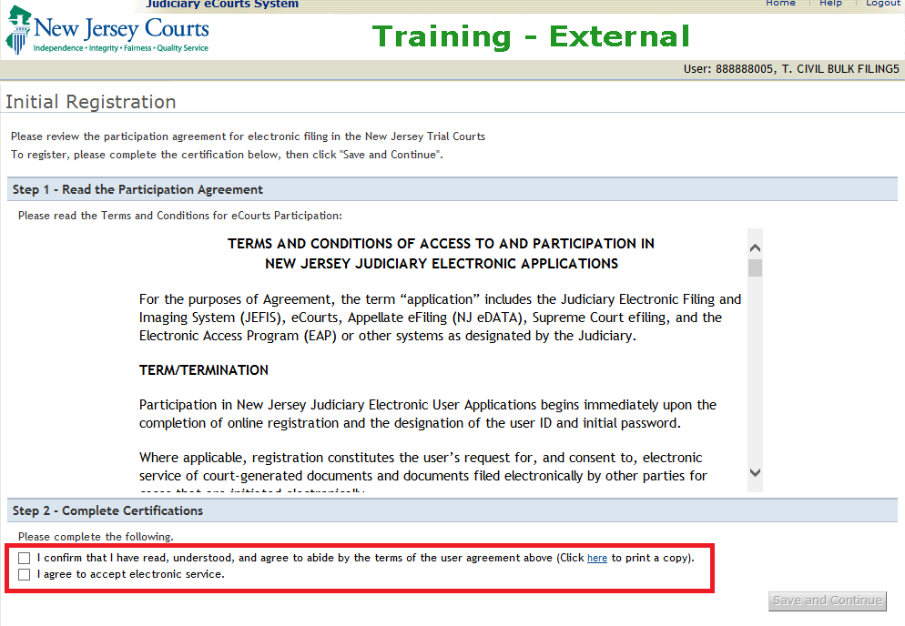

On this screen, select the checkboxes highlighted in Red and click on **Save and Continue**

* On the next screen, update the email addresses where you would like to be notified when a case is filed

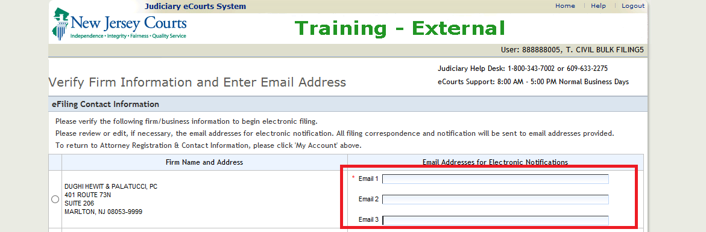

* You can use the case jacket URL to verify the submitted filing and view the uploaded documents, summons and motifications

**Case Jacket URL:**

**Test:** <https://ecourtstraining.judiciary.state.nj.us/webe19/CIVILCaseJacketWeb/pages/civilCaseSearch.faces>

**Production:** <https://ecourts.judiciary.state.nj.us/webe1/CIVILCaseJacketWeb/pages/civilCaseSearch.faces>

# Appendix

## WSDL and Schema

WSDL 

Schema 

## Accepted Values

### Text

A-Z, a-z, 0-9, space, period, dash, $, ?, !, (, ), #, %, comma, slash, single quote, &

### File Name character list

A-Z, a-z, 0-9, .

### Code Tables



## Sample SOAP Messages

### Message1

<**soapenv:Envelope xmlns:soapenv**="http://schemas.xmlsoap.org/soap/envelope/" **xmlns:xsi**="http://www.w3.org/2001/XMLSchema-instance" **xmlns:xsd**="http://www.w3.org/2001/XMLSchema" **xmlns:tns2**="http://webservice.civilfiling.ecourts.ito.aoc.nj/"><**soapenv:Body**><**tns2:submitCivilFiling**><arg0><bulkFilingPacket><attachmentList><contentType>**application/pdf**</contentType><docType>**pdf**</docType><documentCode>**CMPL**</documentCode><documentDescription>**Complaint**</documentDescription><documentName>**Test**</documentName><extention>**.pdf**</extention></attachmentList><attorneyFirmId>**F00004861**</attorneyFirmId><attorneyId>**012152010**</attorneyId><civilCase><caseAction>**028**</caseAction><courtSection>**SCP**</courtSection><defendantCaption>**test def caption**</defendantCaption><demandAmount>**1000**</demandAmount><docketDetailsForOtherCourt>**str**</docketDetailsForOtherCourt><juryDemand>**N**</juryDemand><lawFirmCaseId>**100**</lawFirmCaseId><otherCourtActions>**str**</otherCourtActions><plaintiffCaption>**test plaintiff caption**</plaintiffCaption><serviceMethod>**03**</serviceMethod><venue>**ATL**</venue><venueOfIncident>**ATL**</venueOfIncident></civilCase><defendantList><adaAccommodationInd>**N**</adaAccommodationInd><corporationName>**XYZ Corp**</corporationName><corporationType>**CO**</corporationType><interpreterInd>**N**</interpreterInd><partyAffiliation>**ADM**</partyAffiliation><partyDescription>**BUS**</partyDescription></defendantList><fee><accountNumber>**34550**</accountNumber><attorneyClientRefNumber>**12345**</attorneyClientRefNumber><attorneyFee>**100**</attorneyFee><feeExempt>**N**</feeExempt><paymentType>**CGr**</paymentType></fee><plaintiffList><adaAccommodationInd>**N**</adaAccommodationInd><address><addressLine1>**market st**</addressLine1><city>**Trenton**</city><stateCode>**NJ**</stateCode><zipCode>**12345**</zipCode></address><corporationName>**ABC Corp**</corporationName><corporationType>**CO**</corporationType><interpreterInd>**N**</interpreterInd><partyAffiliation>**ADM**</partyAffiliation><partyDescription>**BUS**</partyDescription></plaintiffList></bulkFilingPacket></arg0></tns2:submitCivilFiling></soapenv:Body></soapenv:Envelope>

### Message2

<**soapenv:Envelope xmlns:soapenv**="http://schemas.xmlsoap.org/soap/envelope/" **xmlns:tns2**="http://webservice.civilfiling.ecourts.ito.aoc.nj/" **xmlns:xsd**="http://www.w3.org/2001/XMLSchema" **xmlns:xsi**="http://www.w3.org/2001/XMLSchema-instance"><**soapenv:Body**><**tns2:submitCivilFiling**><arg0><bulkFilingPacket><attachmentList><contentType>**application/pdf**</contentType><docType>**pdf**</docType><documentCode>**CMPL**</documentCode><documentDescription>**Complaint**</documentDescription><documentName>**Test**</documentName><extention>**.pdf**</extention></attachmentList><attorneyFirmId>**F00004861**</attorneyFirmId><attorneyId>**012152010**</attorneyId><civilCase><caseAction>**028**</caseAction><courtSection>**SCP**</courtSection><defendantCaption>**test def caption**</defendantCaption><demandAmount>**1000**</demandAmount><docketDetailsForOtherCourt>**str**</docketDetailsForOtherCourt><juryDemand>**N**</juryDemand><lawFirmCaseId>**100**</lawFirmCaseId><otherCourtActions>**str**</otherCourtActions><plaintiffCaption>**test plaintiff caption**</plaintiffCaption><serviceMethod>**03**</serviceMethod><venue>**ATL**</venue><venueOfIncident>**ATL**</venueOfIncident></civilCase><defendantList><adaAccommodationInd>**N**</adaAccommodationInd><interpreterInd>**N**</interpreterInd><name><firstName>**Test first name**</firstName><lastName>**Test middle name**</lastName><middleName>**Test last name**</middleName></name><partyAffiliation>**ADM**</partyAffiliation><partyDescription>**IND**</partyDescription></defendantList><fee><accountNumber>**34550**</accountNumber><attorneyClientRefNumber>**12345**</attorneyClientRefNumber><attorneyFee>**100**</attorneyFee><feeExempt>**N**</feeExempt><paymentType>**CGr**</paymentType></fee><plaintiffList><adaAccommodationInd>**N**</adaAccommodationInd><address><addressLine1>**market st**</addressLine1><city>**Trenton**</city><stateCode>**NJ**</stateCode><zipCode>**12345**</zipCode></address><interpreterInd>**N**</interpreterInd><name><firstName>**test first name**</firstName><lastName>**test middle name**</lastName><middleName>**tets last name**</middleName></name><partyAffiliation>**ADM**</partyAffiliation><partyDescription>**IND**</partyDescription></plaintiffList></bulkFilingPacket></arg0></tns2:submitCivilFiling></soapenv:Body></soapenv:Envelope>

Sample Code with test data

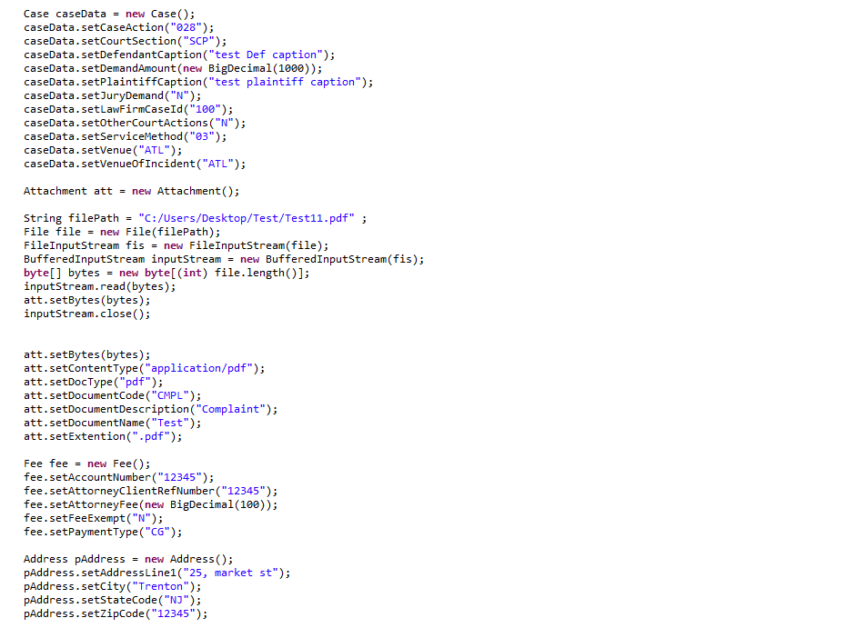

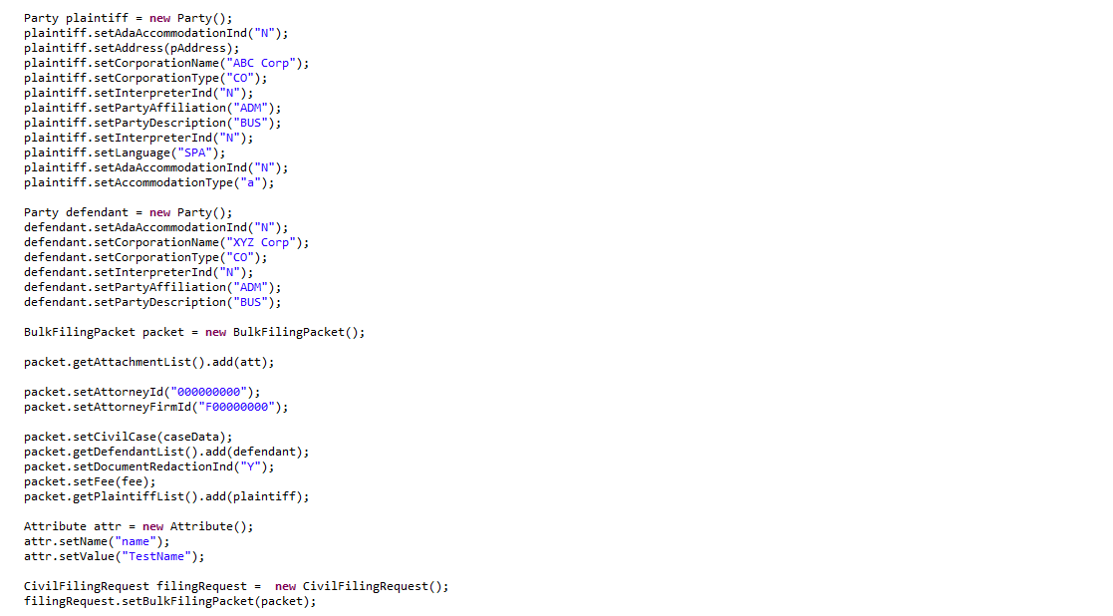

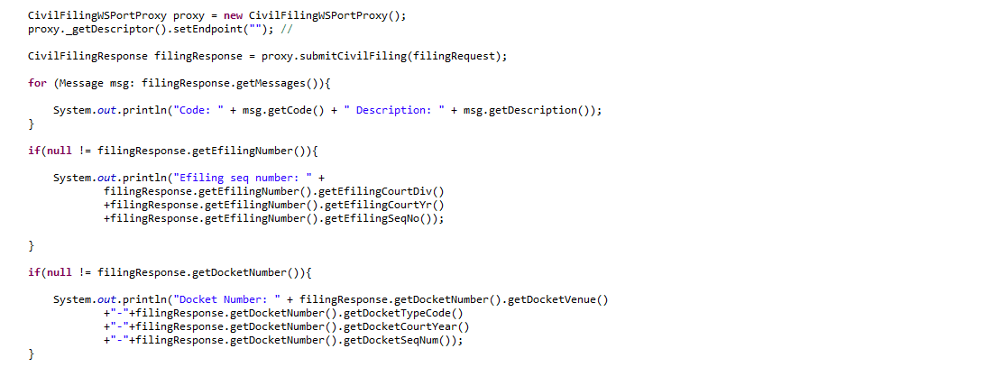

## Sample responses

### Success Response

Code: ECCV500, Message: Filing submitted scuccessfully

Efiling Sequence Number :SCP20168909

Docket Number :ATL-DC-1038-16

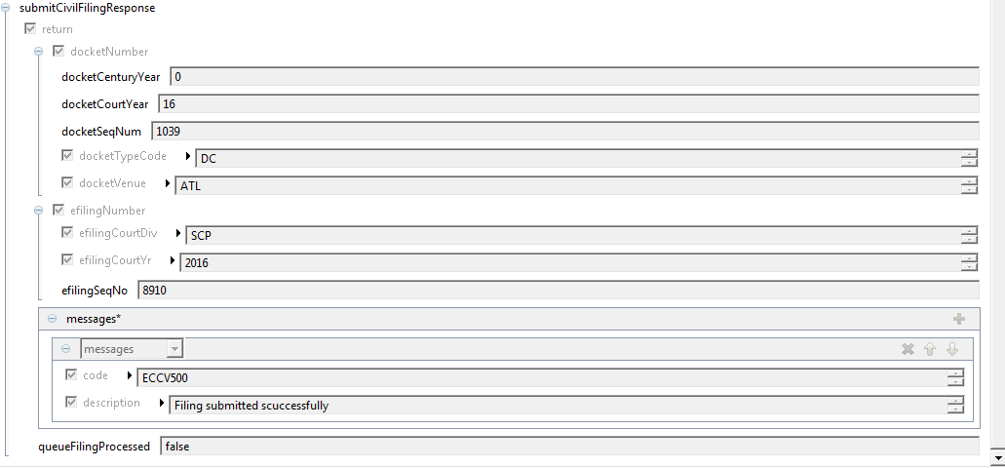

### Failure Response

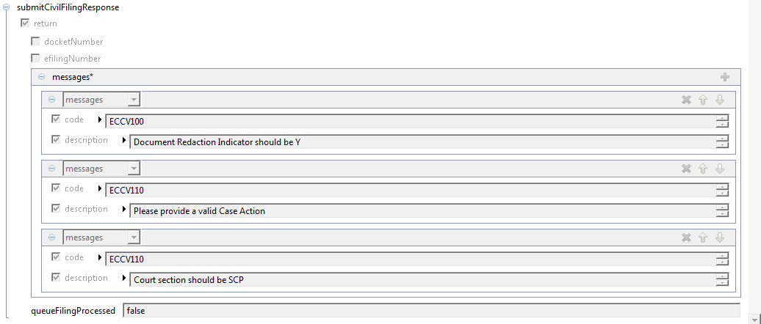

## Class Diagrams

### CivilFilingRequest

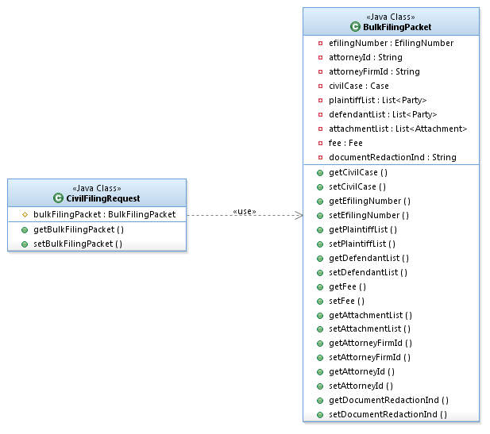

### BulkFilingPacket

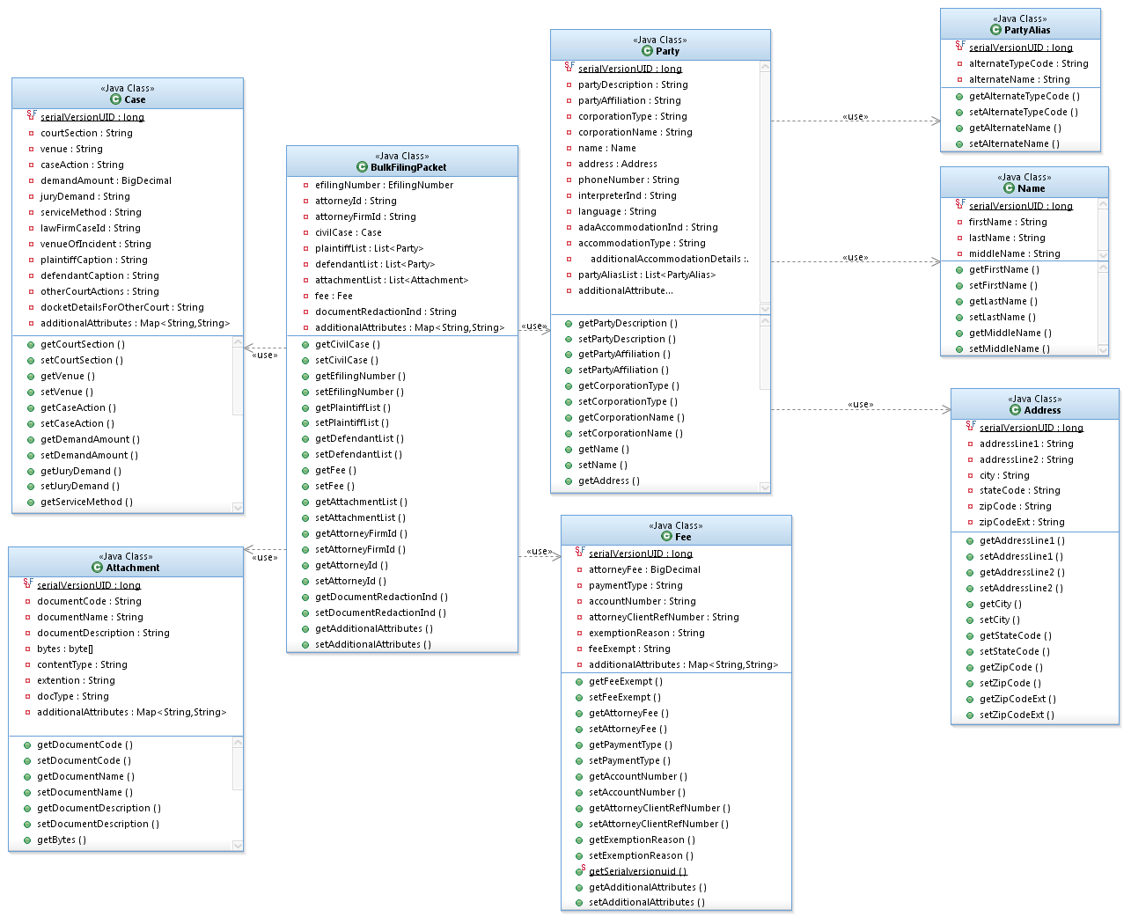

### CivilFilingResponse

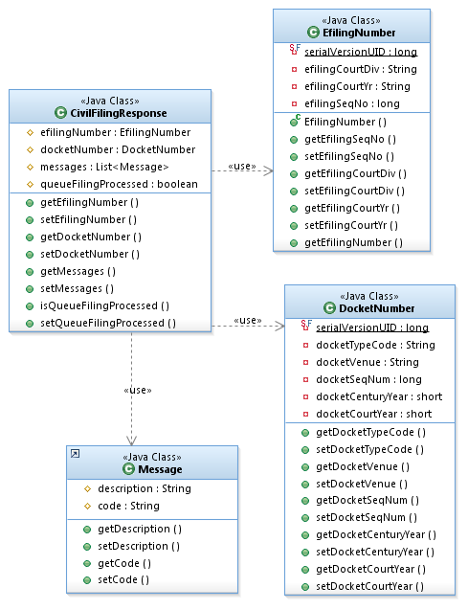

## Frequently Asked Questions

Q: Should the input data follow any sequence when sending the request?

A: Yes, the data has to be in the order of XSD. Refer to the attached XSD in section WSDL and Schema

Q: How do we send the attachements?

A: All the files to be uploaded should be sent as MTOM attachments.

Q: Do we need to send Efiling Number (BulkFilingpacket – Efiling Number) when submitting a filing (SubmitCivilFiling operation)?

A: No, Efiling Number is required only for getCivilFilingStatus operation.

Q: Is there any validation on the documents to be uploaded?

A: There should be always a Complaint (CMPL) document required for filing a civil case. Other document types are optional